
Staff and Volunteer Quick Guide: Safeguarding
Information sharing
All staff understand that child protection issues warrant a high level of confidentiality, out of respect for the pupils, families and staff involved. Staff should only discuss concerns with the DSL/DDSL, Headteacher, Senior Line Manager, Trust Safeguarding team or Chair of Trustees (depending on who is the subject of the concern). That person will then decide who else needs to have the information and will share on a ‘need-to-know’ basis.

Staff should be proactive in sharing as early as possible to help identify, assess and respond to risks or concerns about the safety and welfare of children.

When staff have a safeguarding concern, wherever it is practicable and safe to do so, they should engage with the child and/or their carer(s), and explain who they intend to share information with, what information they will be sharing and why. They are not required to inform or gain consent from parents/carers, if they have a reason to believe that doing so may put the child at increased risk of harm
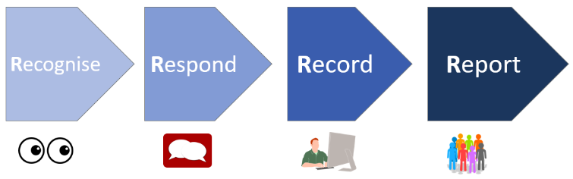
What to do if I have a concern about a child… follow the 4 R’s!

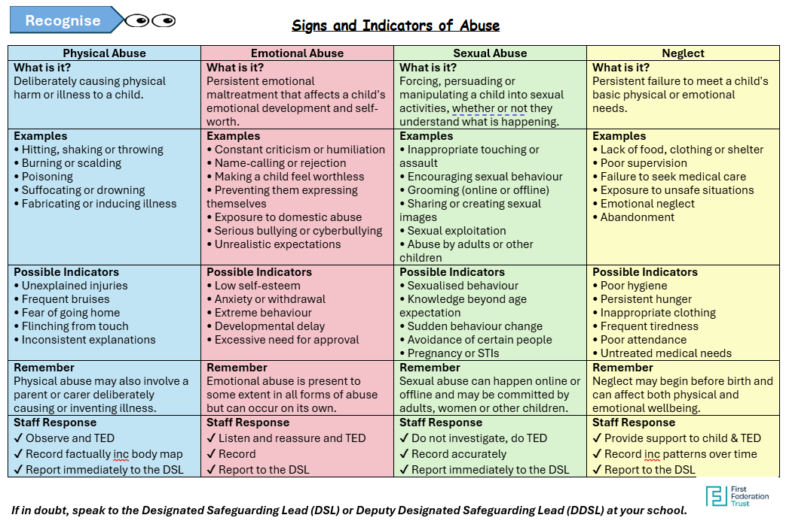

First Federation Trust 4R’s procedure




Respond
Recognise
Report
Record

Safer Working Practices for staff and volunteers
- Be responsible for your behaviour and avoid conduct which would raise concern
- Dress appropriately, i.e. not revealing, no offensive slogans/ripped/torn, underwear to be seen
- Work in an open and transparent way
- Work in an area with the door open and can be visible
- Not to use personal devices to take photographs. Use personal devices in designated areas
- Use professional judgement in situations outside of school within the community, discuss with your line manager as necessary
- Use physical contact that is appropriate for the situation, the age and stage of the child and for a limited duration
- Maintain professional boundaries, inc not making sexual remarks, or humiliating a child
- Discuss concerns / take advice from a senior member of staff, including following policies

